**U01E04 – Php Scripts - II**

Make the following scripts using html and php.

For these scripts that are simple, you paste the code directly after the statement.

1. Develop a php script to:

You should have a variable con 50 numbers from 1 to 100.

* 1. Calculate the arithmetic average of an array of numbers.
  2. Calculate the arithmetic average of an array of numbers excluding the odd numbers.
  3. Calculate the arithmetic average of an array of numbers excluding the numbers that are in an odd position in the array.
  4. Declare a variable with a number between 1 and 10,000 and say how many digits it has.

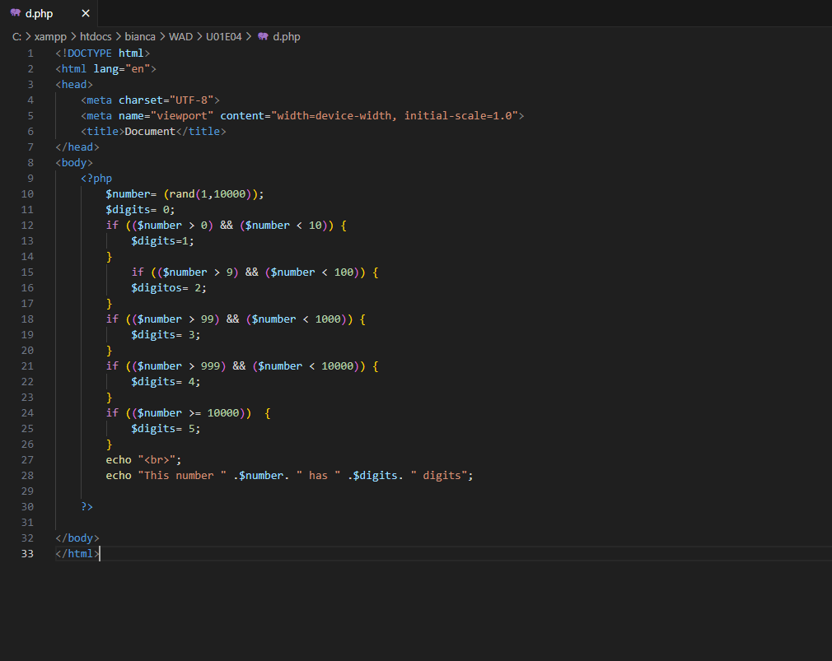

* 1. Read a number and display its square, repeat the process until a number is entered negative.

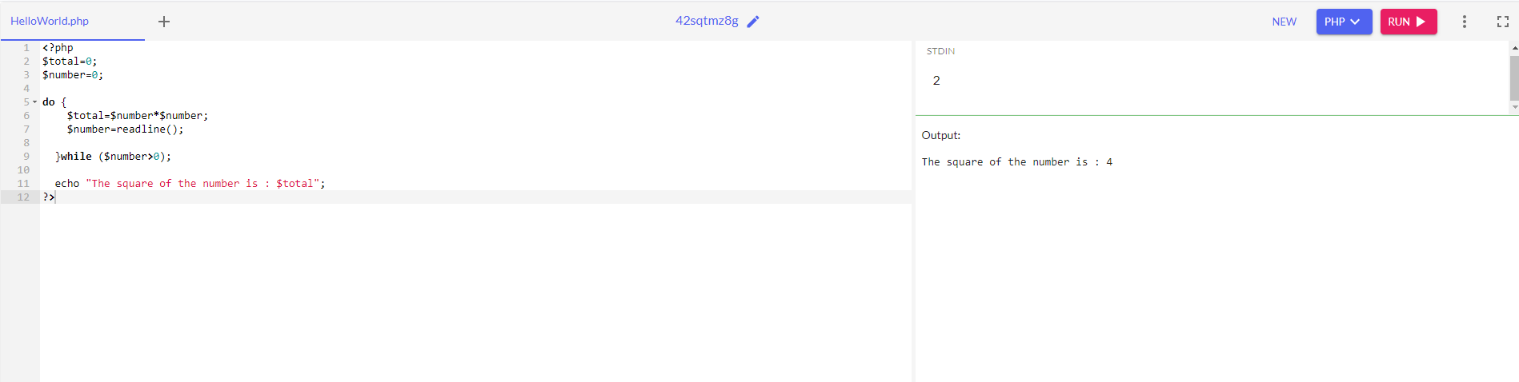

* 1. Prompt for numbers until a 0 is typed, display the sum of all numbers entered.

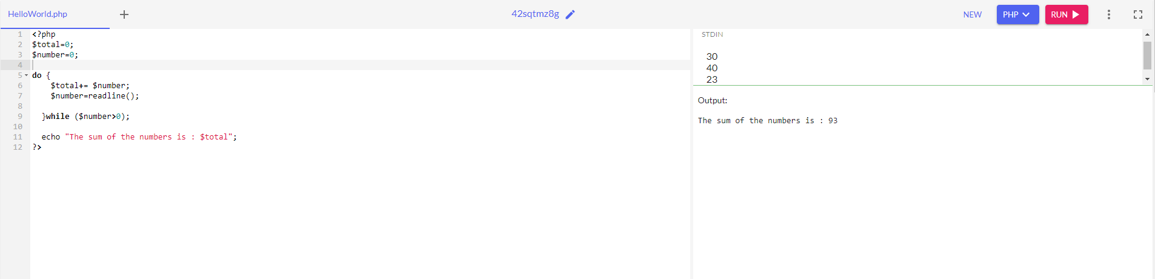

* 1. Ask for numbers until a negative one is entered, and calculate the average.

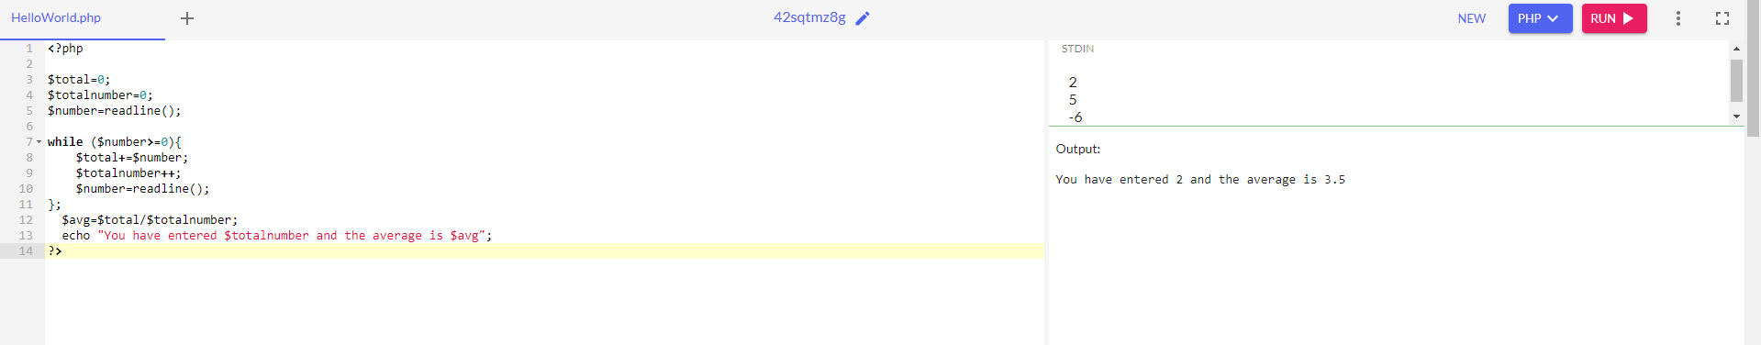

* 1. With an array of numbers. Show the average of the positive numbers, the average of the negative numbers and the number of zeros.

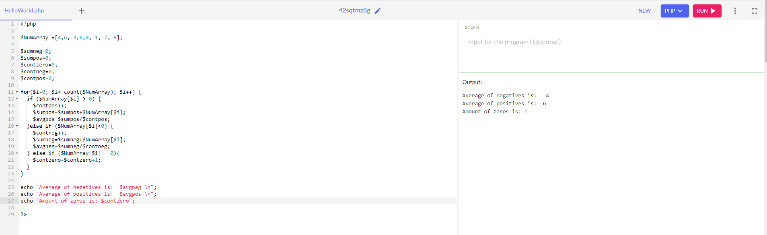

* 1. Ask for a number (which must be between 0 and 10) and show the multiplication table for that number.

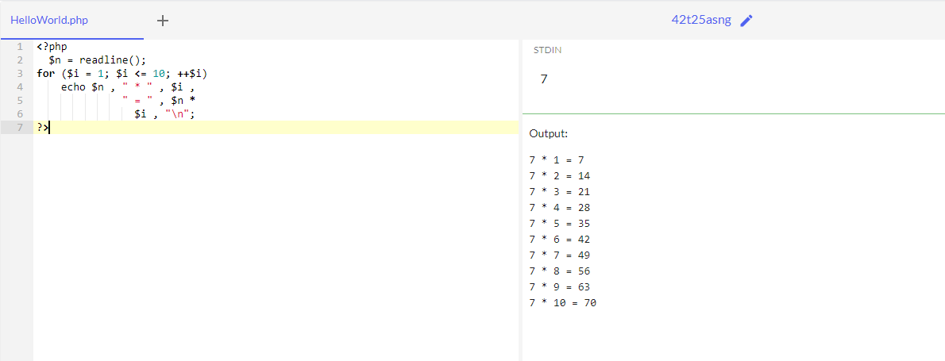

* 1. Design an application that shows the multiplication tables from 1 to 10.

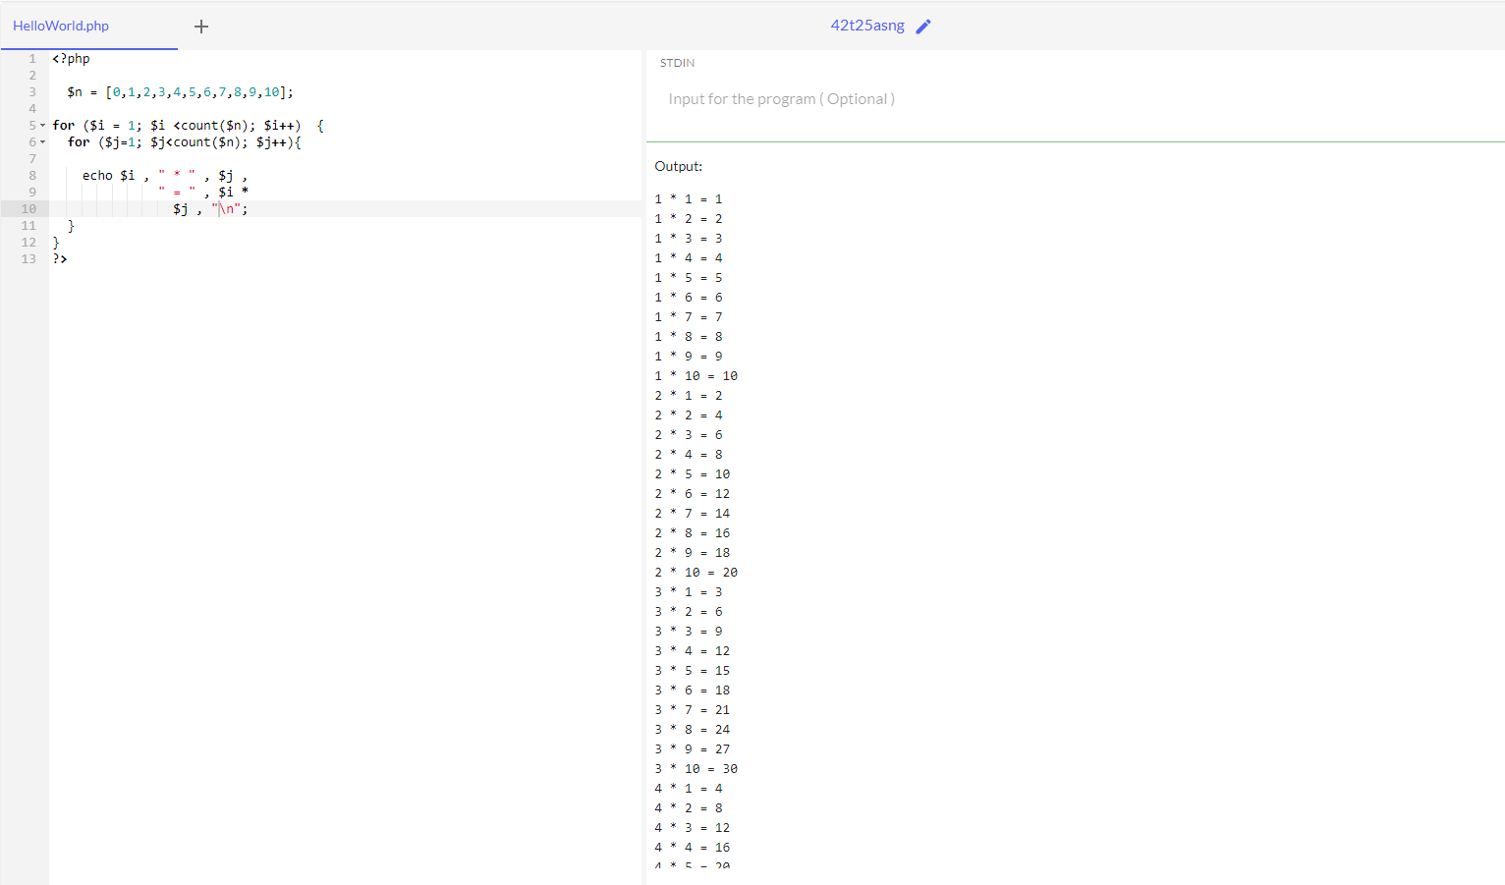

* 1. Draw a square of n elements on each side using *.

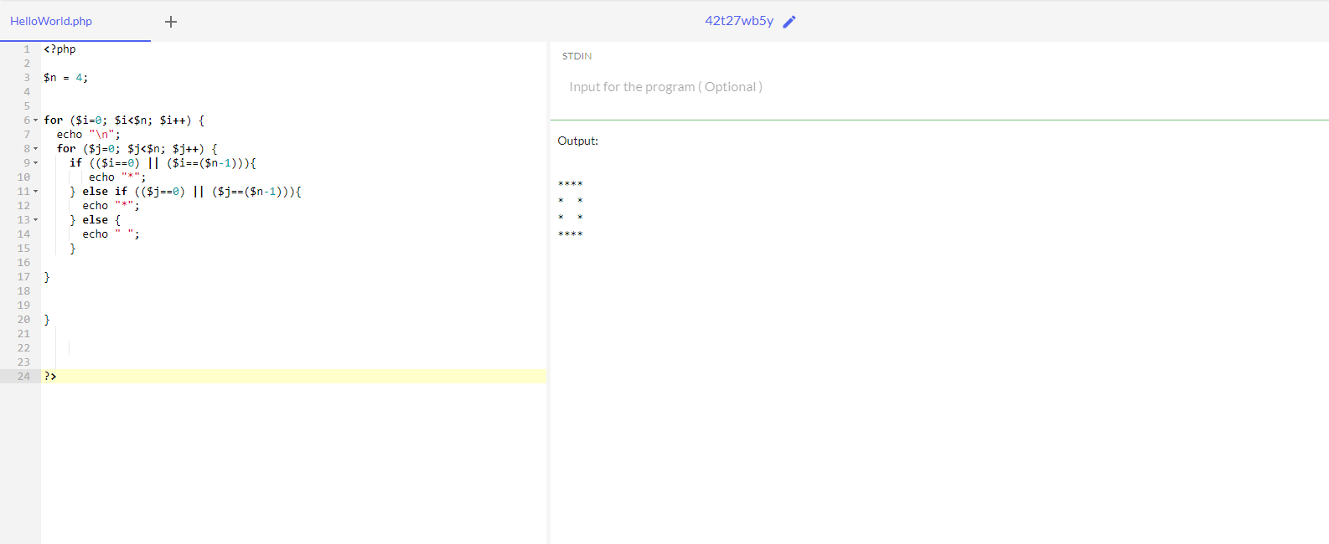

* 1. Create a program that asks us for a number n, and tells us how many numbers there are between 1 and n that are prime numbers.